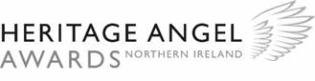
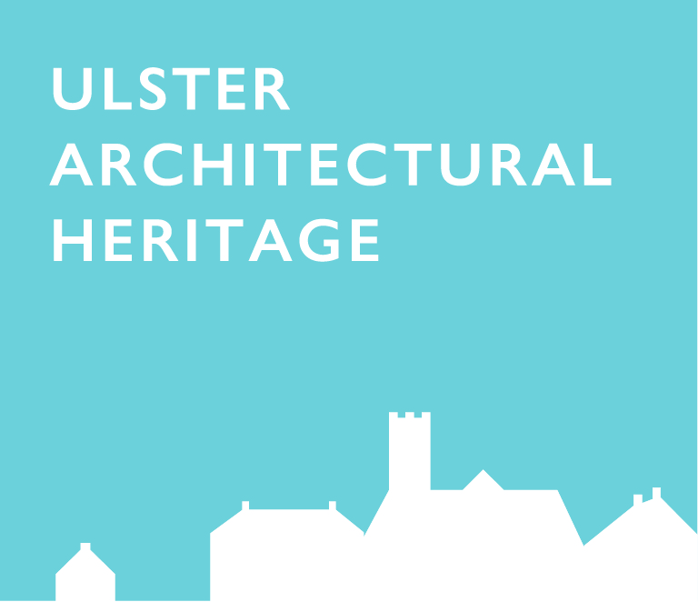
PRESS RELEASE
Heritage Angel Awards – Shortlist Announced

The search for Northern Ireland’s first Heritage Angels is moving forward with the final Heritage Angel Awards shortlist revealed today. These annual awards aim to celebrate unsung angels of local heritage- individuals or groups, who have rescued an historic building or site, worked as craftsmen or apprentices, or recorded and interpreted a historic place.

The Angel Awards are not just about heritage, but the people that make heritage projects happen. Showcasing what is possible when people take interest in and get involved with the care and consideration of our heritage.

Comprising 12 projects across four different categories, the shortlist showcases a range of diverse heritage initiatives across Northern Ireland. The 2017 shortlist includes private owners; volunteers; community groups, commercial owners, apprentices, craftsmen and young people. All of whom have developed their interest in heritage, in different ways and applied their interest into quality schemes in Northern Ireland.

The overall winner in each of the categories will be named at the Northern Ireland Heritage Angel Awards ceremony on Tuesday 7th November at the Grand Opera House, Belfast. The event will also celebrate ‘Heritage in Song’, where local artists including Brigid O’Neill; Duke Special, Anthony Toner and Gareth Dunlop will perform bespoke material around the heritage theme. Tickets are free. All welcome. Book online at: www.uahs.org.uk/events

The Awards are funded by the Andrew Lloyd Webber Foundation; the Department of Communities and the Heritage Lottery Fund. An overall UK winner from the three award schemes, England, Scotland and Northern Ireland, will be selected and celebrated at the London ceremony on Monday 20th November.

We are also asking members of the public to cast their vote for their choice from the shortlist online at www.heritageangelawards-ni.org.uk

Nicola McVeigh, Chief Executive Ulster Architectural Heritage Society
“We were truly overwhelmed with quantity and quality of applications/nominations received in this the first year of the Heritage Angel Awards in Northern Ireland, which has highlighted the strength of interest in preserving our historic buildings and sites for future generations. The awards will run for a further two years and I would encourage anyone who has been unsuccessful this year to reapply in 2018.

Our judges now have the difficult task of finding our overall winners. I’m looking forward to celebrating the success and hard work of all our finalists on 7th November.”

Lord Andrew Lloyd Webber
“Protecting architectural heritage is a vital part of cultural life. Architecture is the most vulnerable art form and one that I have been passionate about all my life. I’m delighted my Foundation can support the Heritage Angel Awards in Northern Ireland and shine a spotlight on those who have made a significant contribution towards protecting the country’s heritage. By raising awareness of the impact individuals can have, our aim is to inspire others to get involved and work together to save and protect Northern Ireland’s heritage for our future generations.’

Full details and films on each of the shortlisted nominee for the Northern Ireland Heritage Angel Wards can be viewed at https://www.heritageangelawards-ni.org.uk/
For more information about the Historic England Angel Awards, visit https://historicengland.org.uk/get-involved/angel-awards/.
For more information about the Northern Ireland Heritage Angel Awards, visit
www.scottishheritageangelawards.org.uk

Notes for editors:

About the Heritage Angel Awards NI The awards are administered by the Ulster Architectural Heritage Society and funded by the Andrew Lloyd Webber Foundation and the Department for Communities. They are further supported by The Centre for Archaeological Fieldwork (CAF); Construction Industry Training Board (CITBNI); Heritage Lottery Fund (HLF); Institute of Historic Building Conservation (IHBC) and Heritage Trust Network (HTN).

For further information on Heritage Angel Awards NI, please contact@

Contact: Maura Ahern, Communications & Events Officer, UAHS
Telephone: 028 90550213
Mobile: 07474306336
Email: events@uahs.org.uk

The Ulster Architectural Heritage Society:
UAHS is a charitable, membership organisation founded in 1967. It exists to promote appreciation, preservation and conservation of architecture across the nine counties of Ulster. Over the last 40 years the UAHS has established itself as a fearless campaigner for buildings of merit, a generous resource of information on local architecture, and a fair and helpful source of advice. Its main activities include campaigning & lobbying, support & advice, publications and events. The UAHS works with the Historic Environment Division, (HED), at the Department for Communities, (DfC), to record and promote the conservation of listed buildings at risk through the Built Heritage at Risk NI, (BHARNI) partnership. www.uahs.org.uk

The Andrew Lloyd Webber Foundation:
The Andrew Lloyd Webber Foundation was set up by Andrew Lloyd Webber in 1992 to promote the arts, culture and heritage for the public benefit; since inception Andrew has been the principal provider of funding for all its charitable activities.
In 2010, the Foundation embarked on an active grant giving programme and has now awarded grants of over £17.5m to support high quality training and personal development as well as other projects that make a real difference to enrich the quality of life both for individuals and within local communities.
www.andrewlloydwebberfoundation.com

About the Heritage Lottery Fund
Using money raised through the National Lottery, the Heritage Lottery Fund (HLF) aims to make a lasting difference for heritage, people and communities across the UK and help build a resilient heritage economy. From museums, parks and historic places to archaeology, natural environment and cultural traditions, we invest in every part of our diverse heritage. HLF has supported almost 35,000 projects with more than £5.3bn across the UK. www.hlf.org.uk.
For full details on how to apply to the 2017 Heritage Angel Awards NI, nominate someone else for an award please visit www.heritageangelawards-ni.org.uk/

Keep up to date with the latest from the Heritage Angel Awards NI on Twitter and Facebook at @ulsterahs

Ends 6 October 2017
